David Rapp Job Pipeline
Canonical Job Pipeline Integration Design

STATUS  Proposed |  | OWNER  David Rapp |  | LAST UPDATED  July 23, 2026

Authors | Codex, under David Rapp's direction
Reviewers | David Rapp; human approval is required for operational adoption
Related docs | candidate-profile-v1.json; daily-job-search-playbook.md; job-service-inbox-router-2026-07-22.md; second-brain-ai-inbox-job-search-handoff-2026-07-22.md
Scope | A canonical, low-energy pipeline from discovery or inbox event through deduplication, resume selection, human approval, and verified writeback.

1. Abstract
This proposal unifies job discovery, inbox events, candidate evidence, resume selection, and application follow-through around one canonical job ledger. Stable identifiers and material-change fingerprints produce delta-only queues, while three established resume families support remote AI/search quality, remote SaaS/product support, and low-voltage field work. Google Drive and Wisebase become publishing and retrieval layers, not competing transaction stores.
Confirmed current on July 23: the automation named daily-remote-job-opportunity-scan is paused, while local profile and playbook files still describe an older scan as active; Drive also contains duplicate strategy and tracker copies. July 22 inbox items are snapshots and must be re-read before action. The referenced chat link was not directly readable, so its corrections are represented only where they also appear in the July 22 playbook: material deltas, prior-action checks, multi-lane search, relocation flexibility, and suppression of recurring-company loops.

2. Goals and Non-Goals
Goals | Non-goals
Surface only net-new or materially changed opportunities and contact events. | Do not auto-apply, send messages, schedule interviews, or contact employers.
Keep one auditable state record with stable keys, provenance, and action history. | Do not make Drive, Wisebase, or email folders separate sources of truth.
Route every actionable item to one of three resume families and one next action. | Do not collapse David's multi-lane search into a recurring AI-evaluation shortlist.
Support a one-action low-energy floor and reversible, bounded automation runs. | Do not redesign the broader Second Brain, SNF, DOV, or job-search stack.

3. Background and Problem Statement
The current system has strong components but weak integration. Local outputs contain a detailed candidate profile, a delta-aware search playbook, three resume variants, a job-inbox router, and a queue. Drive and Wisebase expose older copies of trackers, prompt libraries, and strategy documents. The result is state drift: a paused current automation is described as active in local artifacts; Drive has duplicate career-strategy and tracker files; inbox snapshots can be mistaken for live truth; and prior applications may be resurfaced without checking their current state.
System boundary and invariant: source adapters may read connected tools and public sources, but only the canonical ledger may determine current status. Queues, dated reports, Google Docs, and Wisebase knowledge are derived views. A record can move to an outbound side effect only after current evidence is re-read and David explicitly approves the exact action.

4. Proposed Architecture

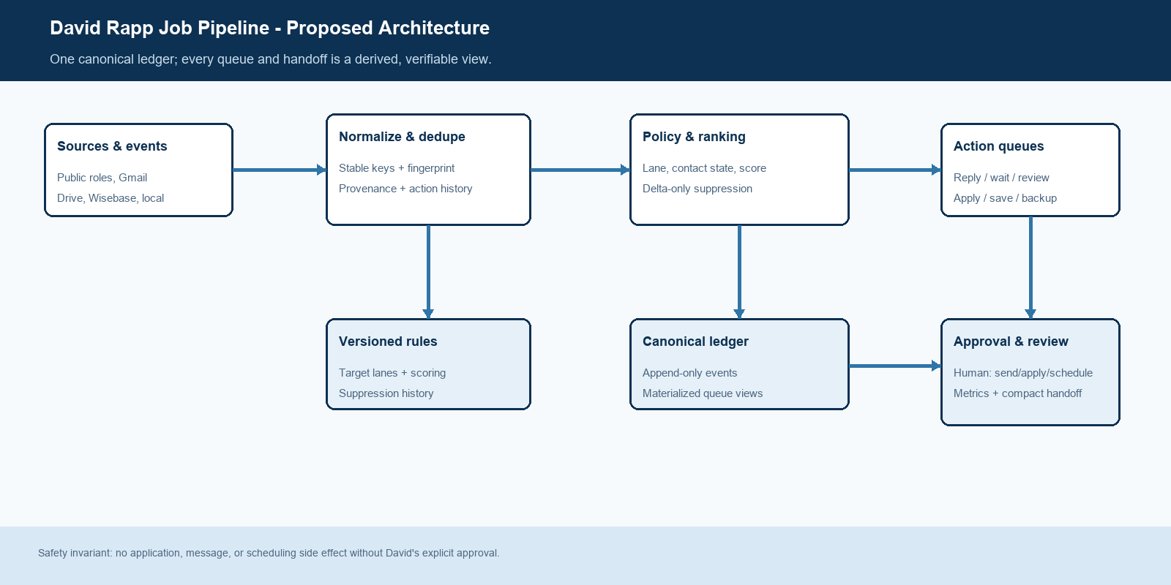
Figure 1. Canonical job-pipeline architecture and approval boundary.

Core components

Component | Responsibility | Primary storage | Failure behavior
Source adapters | Read public job sources, Gmail job threads, Drive files, Wisebase knowledge, GitHub proof, and local artifacts; capture source time and access limits. | Read-only connectors and local file reads | Mark the run partial; never present cached or snapshot state as confirmed current.
Canonical job ledger | Store append-only events and the latest materialized state for each stable lead/contact key. | Local JSON/CSV/Markdown state package | Fail closed on writes; preserve the prior view and emit one repair action.
Dedup and policy router | Normalize identities, compare material fingerprints, classify lane/contact state, score fit, and suppress unchanged repeats. | Versioned rules plus suppression history | Quarantine ambiguous merges and surface the evidence conflict once.
Queue and packet builder | Create reply-now, wait, lead-review, apply-today, save, and backup views; select the correct resume family and next action. | Derived queue views and resume registry | Do not create an action card until required evidence and packet selection are complete.
Approval and review adapter | Require David's approval for send/apply/schedule; then write outcome, emit compact handoffs, and publish selected knowledge to Drive/Wisebase. | Approval event plus dated report | No side effect on missing or stale approval; external publish failure does not alter canonical state.

5. Request Lifecycle
- Ingest — read only high-signal deltas: new inbox events, materially changed roles, updated status, and current candidate evidence.
- Normalize — create a stable lead_key, source timestamp, source confidence, and privacy-safe evidence record.
- Compare — compute the material fingerprint and merge idempotently; unchanged records remain suppressed.
- Classify — assign search lane, contact state, action queue, fit score, and evidence-versus-inference flags.
- Build packet — select one of the three resume families, one next action, and the minimum supporting proof.
- Approve or defer — show the exact send, application, or scheduling action; execute nothing outbound without David's approval.
- Write and learn — append the result, refresh derived queues, emit compact metrics, and publish only the verified handoff layer.

6. API and Data Contracts

Primary data contract

Field | Type | Required | Description
lead_key | string | Yes | Normalized company + role + source identity; stable across repeated scans and alerts.
event_id | string | Yes | Unique source event or write attempt; makes ingestion and replay idempotent.
lane | enum | Yes | ai_search_quality, saas_support, ops_trust_safety, field_runway, or prs_care.
contact_state | enum | Yes | discovered, saved, applied, reply_now, waiting, interview, rejected, offer, stale, or closed.
material_fingerprint | sha256 | Yes | Hash of decision-relevant fields; unchanged fingerprints may not be resurfaced as new.
evidence[] | object[] | Yes | Source, observed_at, confidence, and privacy-safe excerpt; inference is labeled separately.
execution | object | Yes | Resume family, queue, next action, approval state, policy version, updated_at, and outcome.

Contract guarantees

- Canonical-before-side-effect: the ledger write and current-evidence check must succeed before an outbound action is offered.
- Stable lead_key and unique event_id make duplicate ingestion, retries, and replay safe.
- Every decision captures policy version, candidate-profile version, source timestamps, and resume family.
- The ledger is authoritative for pipeline state; Drive, Wisebase, reports, and queues are discoverable projections.
Proposed versioned schema: job-pipeline-schema-v1.json, stored beside the canonical state package.
[Link to interface or schema]This design specifies the contract but does not create or activate the transactional implementation.

7. Consistency, Idempotency, and Replay

Merges are deterministic by lead_key, event order, and source precedence. Append-only events preserve reconstruction; materialized views may be rebuilt. A newer verified employer or applicant event outranks an older scan result. Ambiguous company-role matches remain separate until reviewed. Replays may repeat reads, but they may not duplicate queue cards, tracker rows, applications, or messages.
Scenario | Expected behavior | Reasoning
Duplicate or repeated input | Merge the event; keep the existing queue state unless the fingerprint changed. | Prevents recurring-company loops and false net-new yield.
Required source or ledger write fails | Emit partial/blocked status, preserve prior state, and identify the smallest repair. | Stale evidence is never promoted to current truth.
Outbound action requested | Require a fresh source read and an explicit approval event; otherwise defer. | Protects David from unintended applications, messages, or scheduling.
Policy changes during a run | Finish under the recorded policy version; apply the new version on the next event. | Keeps ranking and suppression decisions explainable and replayable.

8. Security and Privacy Considerations

- Use connector-native authentication; never copy credentials, tokens, full mailbox contents, or private attachment payloads into the ledger.
- Store the minimum evidence needed to explain fit and state; redact phone, full address, and private email from shared artifacts.
- Keep candidate proof accurate: State Not Fate is portfolio evidence, not formal employer history or clinical licensure.
- Administrative replay and debugging are read-only by default; publish and outbound actions are separately approved.
- Retain dated events long enough to suppress duplicates and explain decisions; deletion policy remains an open implementation decision.

9. Operational Readiness
Signal | SLO or alert | Owner | Launch gate
Net-new viable leads / token yield | Report viable decisions by lane; zero is valid. Do not count raw sources scanned. | Job-pipeline owner | Required
Reply-now latency | Verified human contact surfaced within 24 hours of detection. | Inbox router | Required
Unchanged repeat rate | 0 items mislabeled net-new when fingerprint is unchanged. | Dedup router | Required
Packet completeness | 100% of apply/reply cards name resume family, proof, and next action. | Packet builder | Required
State reconciliation | 100% of queue rows have current contact state and source timestamp. | Canonical ledger | Required
Rollout constraint: begin with a dry run, then validate one live inbox or lead event. Keep all outbound actions approval-gated. Re-enable or create any recurring automation only after David explicitly approves its bounded cadence, source set, writebacks, and stop rule.

10. Alternatives Considered

Alternative | Why it was considered | Why it was not selected
Google Drive as source of truth | Easy sharing and existing resume/strategy files. | Duplicate copies and weak transactional state make drift likely.
Wisebase as transaction store | Strong retrieval and cross-document synthesis. | Knowledge retrieval is not the right authority for exact contact and approval state.
Email-only workflow | Human contacts and application confirmations are high-value signals. | It misses public discovery, resume/proof selection, and deduplicated history.
Fully autonomous application agent | Maximum apparent throughput. | It violates approval boundaries and optimizes volume over evidence-backed fit.

11. Open Questions
- Canonical location — keep transactional state in the existing local job-search workspace, or promote a dedicated folder after the schema dry run?
- Cadence — after the paused automation is corrected, should discovery be event-driven, one bounded daily run, or a hybrid with a weekly review?
- Evidence retention — how long should closed or rejected records remain available for duplicate suppression and learning?
- Inbox writeback — should approved status changes update only the ledger, or also a human-readable tracker projection?

12. Decision and Next Steps
Decision proposed: adopt a local canonical job ledger and versioned policy/router; treat Gmail, public sources, Drive, Wisebase, and local files as evidence inputs; treat queues, Google Docs, dated reports, and Wisebase knowledge as projections. Preserve the three resume families and the July 22 delta rules. Before any recurring automation is resumed, reconcile stale identifiers/status, dry-run the contract, and validate one current event with David's approval.
Milestone | Deliverable | Exit criteria
M1 | Create job-pipeline-schema-v1 and a canonical resume/source registry. | Schema covers keys, evidence, queues, approval, and policy version; stale automation labels are identified.
M2 | Dry-run router against the July 22 queue and latest scan artifacts. | No unchanged lead is resurfaced; every actionable card has one resume and one next action.
M3 | Validate one current inbox or lead event with human approval. | Fresh source read, correct state transition, exact approval, and verified writeback.
M4 | Propose a bounded recurring automation and knowledge-publish cadence. | David approves sources, cadence, token ceiling, writebacks, and stop rule before activation.
Next tiny move: re-read the highest-priority live job event, map it to a resume family and ledger state, and ask David to approve only that exact next action.

Use footnotes for definitions, assumptions, or terms that need precision without interrupting the main narrative.

